APPLICATION FOR EMPLOYMENT

INSTRUCTIONS: Complete all necessary information. This application will be kept on file for 60 days. Answer all questions completely, sign and date where indicated. Please print.

NAME SOC SEC#

ADDRESS

TELEPHONE
(Primary) (Message or Work)

EMAIL ADDRESS

Are you between the ages of 16 and 70?

Do you have a legal right to be employed in the United States? If yes, proof is required.

Have you previously worked for CPCC If yes, when?

If you were referred for employment by a current employee, please indicate newspaper ad; walk-in or other

Have you ever been convicted of a violation of law applicable to this position, other than a minor traffic violation? If yes, please explain:

NOTE: A conviction record is not an automatic bar to employment

POSITION APPLYING FOR: (List in order of preference)
1. 2.

3. 4. THIS APPLICATION IS FOR: Full Time Part Time Permanent Temporary
Shift Preferred: List in order of preference)
1. 2. 3.

Date available for work MINIMUM SALARY REQUIRED:

PERSONAL REFERENCES:
(Other than family members or previous employers who have knowledge of your skills and abilities in the area for which you have applied)

NAME PHONE

ADDRESS

NAME PHONE

ADDRESS

EDUCATIONAL BACKGROUND
(Circle highest level completed)

GRAMMER SCHOOL 5 6 7 8 VOCATIONAL TRAINING

HIGH SCHOOL 9 10 11 12 GRADUATE DEGREE

COLLEGE 1 2 3 4 TRAINING IN WHAT FIELD

NAME OF LAST SCHOOL ATTENDED

LICENSES HELD:
(List type and number)

PREVIOUS EMPLOYERS AND THEIR ADDRESSES:
Place an X by the employer(s) you do not want us to contact. List the most recent employer first. COMPANY NAME PHONE
ADDRESS

SUPERVISOR EMPLOYED FROM TO

POSITION HELD LAST WAGE

REASON FOR LEAVING

JOB DUTIES

COMPANY NAME PHONE

ADDRESS

SUPERVISOR EMPLOYED FROM TO

POSITION HELD LAST WAGE

REASON FOR LEAVING

JOB DUTIES

COMPANY NAME PHONE

ADDRESS

SUPERVISOR EMPLOYED FROM TO

POSITION HELD LAST WAGE

REASON FOR LEAVING

JOB DUTIES

PLEASE READ AND SIGN BELOW

I certify and agree as follows:

That evidence of false statements on this application will be considered sufficient cause for immediate disqualification as a candidate for employment or immediate discharge if already employed.

That, if employed, I am employed on an at-will basis and may be terminated at any time either by me or my employer, with or without cause.

I understand that if hired, and it is suspected that I am under the influence of alcohol or drugs while in the facility, I will be required to obtain either a blood or urine test with grounds for immediate termination in the case of positive results.

If selected for hire, I will obtain a pre-employment physical paid for by Community Pride Care Center. The physician and cost must have prior approval from the Administrator of the facility and the physician must certify that I am able to work before I actually begin employment.

If my job requires certification and/or education requirements, I am willing to complete the course and testing in a timely manner.

I understand that the Immigration Reform and Control Act of November 6, 1986 requires me to prove the legality of my residency or citizenship. I am also aware that the failure to provide such proof at the time of request may legally force my termination.

I understand that Community Pride Care Center is an Equal Opportunity Employer. All qualified persons are welcome to submit applications for employment. Applicants will be selected solely on qualifications without regard to age, sex, race, color, religion or national origin. I understand that a portion, or all, of my references will be checked and I authorize Community Pride Care Center to contact them.

I authorize my previous employers to release information regarding my employment, including evaluations.

I authorize Community Pride Care Center to release specific employment information to places where I have filed an employment application whether during or after my employment at Community Pride Care Center.

Signature Date

This application remains in effect for 60 days.

NEBRASKA
Division of Medicaid and Long-Term Care
Provider Release of Information Felony/Misdemeanor Statement

I understand that the Nebraska Department of Health and Human Services requires the following background information on me. History may be requested from law enforcement or criminal justice agencies, including but not limited to:
- State of Nebraska Adult/Child Abuse and Neglect Central Registry. Law Enforcement Records
The State of Nebraska Sex Offender's Registry
- The Nebraska Department of Motor Vehicles Nebraska Driver License Information System
- License Information System
- GSA website http://epls.gov for debarment actions by federal agencies and exclusion actions from Medicare, Medicaid or other federal programs through the Office of Inspector General at www.oig.hhs.gov/fraud/exclusions.asp

0 I am applying to provide services OUTSIDE OF THE CLIENT'S HOME. Location:

If you will be providing services in your home or someone else's home, the Department requires background information on all members of that household including full names, previous names, birthdates and Social Security numbers on all persons living in that residence and any criminal background information. I understand this information is required in determining my approval as a service provider. Complete page 3 if needed.
0 I am applying to provide services IN THE HOME OF A CLIENT.
No other persons will be involved in the provision of these services. Therefore, no other persons will need to be cleared with the Department in determining my approval as a service provider
Agency/Assisted Living Employee: DHHS shall review employer policies regarding hiring and reporting to ensure that appropriate procedures regarding abuse/neglect are in place. In addition, employees will complete this form.

Name of Agency/Facility Community Pride Care Center ALF
City
Battle Creek

Position Date of Hire

NAME (Print:)

First Middle Last PREVIOUS NAMES:

(List All Previous Married, Maiden or Other Legal Names or Write NONE)

SOCIAL SECURITY#: DATE OF BIRTH: GENDER:

CURRENT ADDRESS:

List each residence in the last 10 years (Add rows as needed)
COUNTY CITY STATE DATE

MC-199 Rev. 1/11 (34048) Page
Previously MILTC-1500

ON BACK

My Record of Felonies/ Misdemeanors I Arrests and I or Convictions and any pending charges is as follows:
List details including dates and disposition i.e. Parole Probation Fine Time Served etc. OR "NONE") (Add rows as needed)

Offense Date
City
State
Outcome

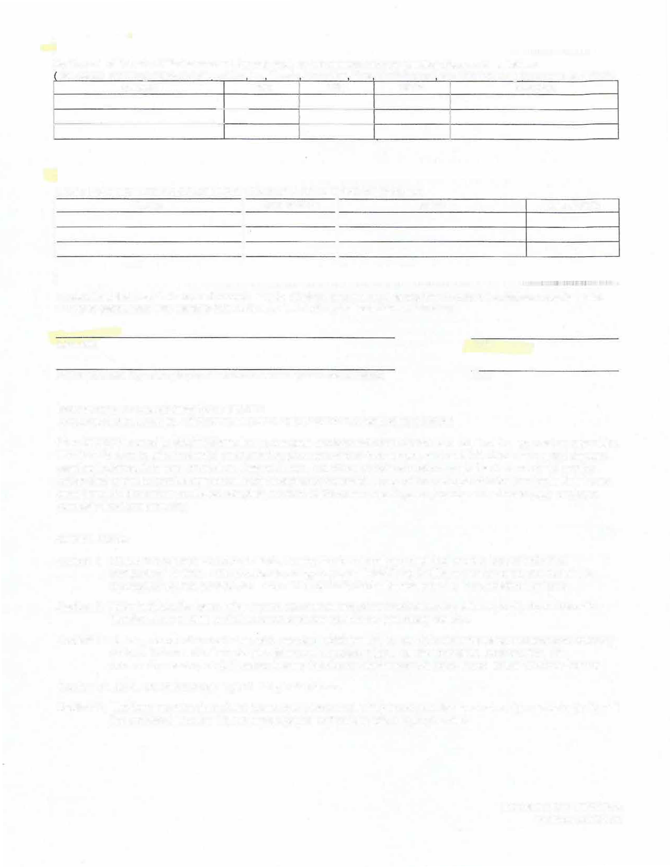
INAMES AND BIRTHDATES OF CHILDRENITHROUGH AGE 12 LI IVING IN MY HOME:
Name
Date of Birth
Name
Date of Birth

I understand that Law Enforcement records may be obtained and reviewed at any time to determine the above statements. Any false statements may result in termination or denial of any independent contractors.

Signature Date

Parent/Guardian Signature (Required if individual is under the age of 19 and not married) Date

Instructions for Completing Form MC-199
PROVIDER RELEASE OF INFORMATION/FELONY MISDEMEANOR STATEMENT
Form MC-199 is used to obtain information to complete background checks which are required for approval as a provider. This form is used to allow potential and renewing providers and/or their employees to self-disclose any current charges, pending indictments or any convictions they have had. Individual providers must complete the form every 12 months before their provider service agreement may be signed or renewed. For providers who provide the service in their home, each household member must also complete the form at the same time. Agency providers must have each employee complete this form annually.

COMPLETION:
Section I: Check the appropriate boxes to indicate why the form is being completed and the type of individual completing the form. If the provider is an agency or assisted living facility, enter the name and city of the agency/facility, the position and date of hire of the individual employee who is completing the form.
Section II: Enter individual's name, other names used (including other married names, aliases, etc.), Social Security Number, date of birth and all addresses where he/she has previously resided.
Section 111: List any record of current charge(s), pending indictment(s), or conviction(s) regarding misdemeanor or felony actions. This must include details, dates and disposition (e.g., parole, probation, incarceration, fine, community service, etc.). If person has no felonies or misdemeanors, write "none" in the "Offense" column.
Section IV: List all children through age 12 living in the home.
Section V: The form must be signed and dated by the individual. The parent/guardian must also sign and date the form if the individual is under 19, not emancipated, or if he/she has a legal guardian.

MC-199 Rev. 1/11 (34048) Page
Previously MILTC-1500

DISCLOSURE AND AUTHORIZATION FOR CONSUMER REPORTS

In connection with my application for employment (including contract or volunteer services) with Community Pride Care Center, I understand consumer reports will be requested by (The Company). These reports may include, as allowed by law, the following types of information, as applicable: names and dates of previous employers, reason for termination of employment, work experience, reasons for termination of tenancy, former landlords, education, accidents, licensure, credit, etc. I further understand that such reports may contain public record information such as, but not limited to: my driving record, workers’ compensation claims, judgments, bankruptcy proceedings, evictions, criminal records, etc., from federal, state, and other agencies that maintain such records.

In addition, investigative consumer reports (gathered from personal interviews, as applicable, with former employers or landlords, past or current neighbors and associates of mine, etc.) to gather information regarding my work or tenant performance, character, general reputation and personal characteristics, and mode of living (lifestyle) may be obtained.

If I am hired, I understand that my employer can use this disclosure and authorization to continue to obtain such consumer reports throughout my employment, contract period or volunteer service.

Authorization

I hereby authorize procurement of consumer report(s) and investigative consumer report(s) by Company. If hired (or contracted), this authorization shall remain on file and shall serve as ongoing authorization for Company to procure such reports at any time during my employment, contract, or volunteer period. I authorize without reservation, any person, business or agency contacted by the consumer reporting agency to furnish the above- mentioned information.

This authorization is conditioned upon the following representations of my rights:

I understand that I have the right to make a request to the consumer reporting agency: Private Eyes Screening Group (“Agency”), 9080 Double Diamond Parkway #B, Reno, NV 89521, telephone number (925) 927-3333, upon proper identification, to obtain copies of any reports furnished to Seller by the Agency and to request the nature and substance of all information in its files on me at the time of my request, including the sources of information, and the Agency, on Company’s behalf, will provide a complete and accurate disclosure of the nature and scope of the investigation covered by any investigative consumer report(s). The Agency will also disclose the recipients of any such reports on me which the Agency has previously furnished within the two-year period for employment requests, and one year for other purposes preceding my request (California three years). I hereby consent to Company obtaining the above information from the Agency. I understand that I can dispute, at any time, any information that is inaccurate in any type of report with the Agency. I may view the Agency’s privacy policy at their website: www.privateeyesbackgroundchecks.com.

I understand that if the Company is located in California, Minnesota or Oklahoma, that I have the right to request a copy of any report Company receives on me at the time the report is provided to Company. By checking the following box, I request a copy of all such reports be sent to me. Check here: □

As a California applicant, I understand that I have the right under Section 1786.22 of the California Civil Code to contact the Agency during their hours of operation (5:00 a.m. to 5:00 p.m. (PST) Monday through Friday) to obtain all information in Agency’s file for my review. I may obtain such information as follows: 1) In person at the Agency’s offices, which address is listed above. I can have someone accompany me to the Agency’s offices. Agency may require this third party to present reasonable identification. I may be required at the time of such visit to sign an authorization for the Agency to disclose to or discuss Agency’s information with this third party; 2) By certified mail, if I have previously provided identification in a written request that my file be sent to me or to a third party identified by me; 3) By telephone, if I have previously provided proper identification in writing to Agency; and 4) Agency has trained personnel to explain any information in my file to me and if the file contains any information that is coded, such will be explained to me.

I understand that if I am applying for employment in New York, that I have the right to receive a copy of Article 23-A of the New York Correction Law (initial if this applies).

I understand that if the report is provided to an employer in the State of Washington, that I can contact the following office for more information regarding my rights under Washington state law in regard to these reports: State of Washington Attorney General, Consumer Protection Division, 800 5th Ave, Ste. 2000, Seattle, Washington 98104-3188, (206) 464-7744.

In connection with my application for employment, I direct the following regarding my current employer: (please check one). Yes, my current employer may be contacted / No, my current employer cannot be contacted

I understand that I have rights under the Fair Credit Reporting Act, and I acknowledge receipt of the Summary of Rights (initials).

Printed Name:

Signature:

Date:

For identification purposes only:

Social Security No.: Date of Birth: .

Driver License No.: State of Issue: .

Present Address: Previous Address 1: Previous Address Dates: (MM/YY): / to /
Previous Address 2: Previous Address Dates (MM/YY): / to /
Please attach a separate page if you have additional addresses.

*If under the age of 19, both you and your parent (or responsible party) must sign and date below and have it notarized.

Applicants Signature: Date (MM/DD/YYYY): -

Parent (Responsible Party) Signature: Date (MM/DD/YYYY):

Notary Public Signature: Date (MM/DD/YYYY):

STAMP HERE:

2

